ZD,
REPORT OF JOINT INVESTIGATION VISIT BY NOSDRA, DPR, SPDC, RIVERS STATE MINISTRY OF ENVIRONMENT AND GIO COMMUNITY REPRESENTATIVES AT 28” NKPOGU – BOMU (TNP) PIPE LINE @ GIO IN TAI L.G.A OF RIVERS STATE.
INTRODUCTION
Acting on your directives on the SPDC request, a Joint Investigation Visit (JIV) was conducted at the 28’’ Nkpogu – Bomu (TNP) Pipe Line at GIO in TAI L.G.A of Rivers State on the 20th of August, 2015 at about 11:15Hrs. The investigation was completed successfully on the same day. This report provides details.
INCIDENT PARTICULARS: 2015_ 1465510
FACILITY AFFECTED: 28’’ NKPOGU - BOMU TNP @ GIO TAI IN RIVERS STATE.
DATE OF SPILL: 19/08/2015
DATE OF INSPECTION: 20/08/2015
CAUSE OF SPILL: SABOTAGE (Hack saw cut see Fig.1a & b)
QUANTITY OF CRUDE OIL SPILLED: 143.06bbls (144.0bbls)
SPILL POINT COORDINATES: N 04^{O} 51’ 35.2’’
E 007^{O} 08’ 09.2”
NATURE OF IMPACT: Moderate
INVESTIGATION TEAM:
- Koms Abam NOSDRA
- Gerard Onuigbo SPDC - OSRT
- Dambani Samuel SPDC - CRD
- Tony Okoro SPDC – HSE LAND
- Chibuike Chibuzo DPR
- Glory A. Wonte RIVERS STATE MINISTRY OF ENVIRONMENT
- Gad Vitus GIO TAI COMMUNITY

OBSERVATIONS:
- The Spill occurred within and out of SPDC ROW (See Fig. 3b) and the Spilled Area was gutted by fire (See Fig. 2a) which affected the Vegetation and Economic Trees; like Palm Trees, Mango, Local Pear, Coconuts etc around the Area (See Fig. 2b attached)
- The Topography of the Area was plan ground with a hip of Top Soil on one side that naturally served as containment for the expelled Crude Oil (See Fig. 2a). Though Dykes were latter dug after the fire had been put-off to further contain the Contaminant (See Fig. 4a).
- The excavation was done by Mechanical means and the Soil Type was Silt (See Fig. 3a).
- It was a clear case of Sabotage – Hack Saw Cut, 170mm long with 100mm Active Point at 12 O’clock Position (See Fig.1)
- Repair work was done on the 28” TNP and the area back-filled (See Fig. 4b)
ISSUES OF CONCERN - FEED BACK
- It was observed that a JTF Camp was just about 200M away from the Spill Point, one wonders how this could have happened with the close proximity to the Camp.

RECOMMENDATIONS
- At the time of JIV 100 Barrels of Crude Oil were recovered, though the Total Quantity Spilled was approximately 144 Barrels within the 1,100M², hence clean-up is required.
- Surveillance of facilities need to be intensified to prevent future re-occurrence
- SPDC should look into this issue of JTF Camp located just close to the area but sabotage activity was still carried out.
CONCLUSION
The JIV was successful. This report is subject to your steer and further directives.

Koms Abam
SES
_____________________________
21st August, 2015

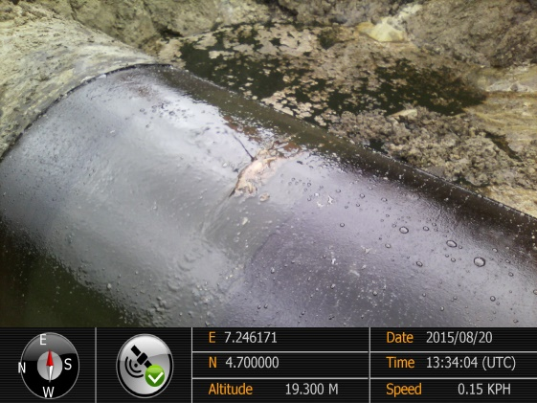 ` 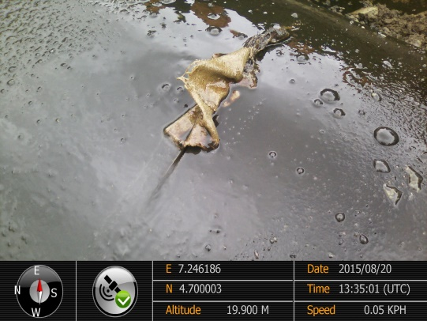
Fig. 1a 170mm Hack Saw Cut Fig.1b @ 12 O’clock Position
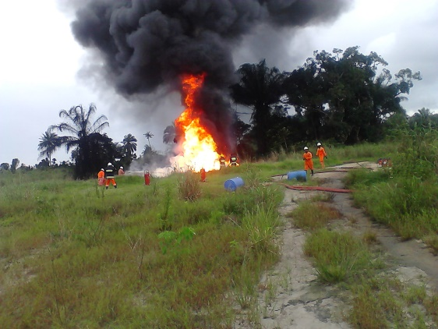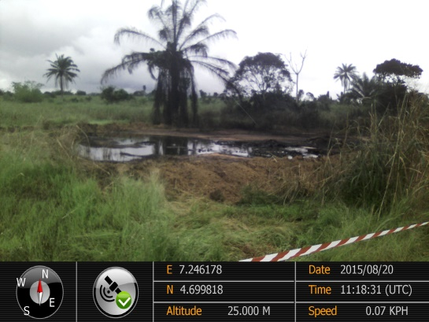
Fig. 2a Spill Area gutted by Fire Fig. 2b Vegetation/Economic Tress Affected.
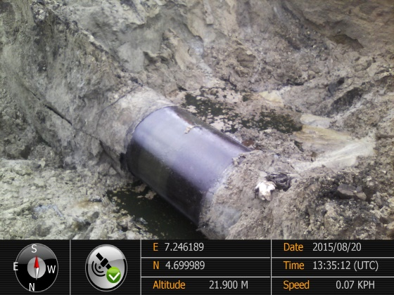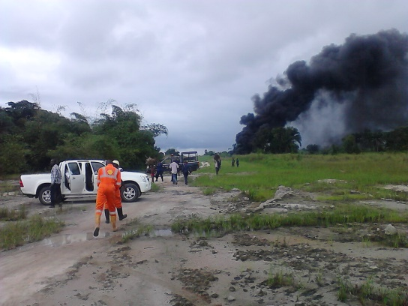
Fig. 3a Soil Type SILT Fig. 3b Spill within ROW
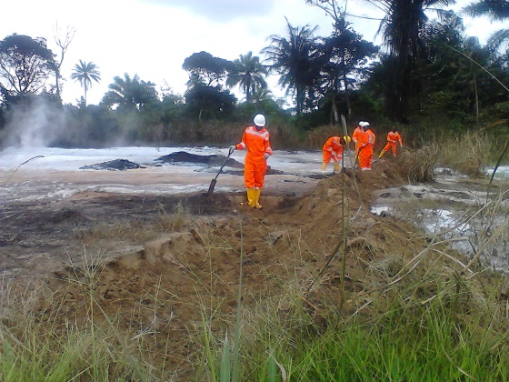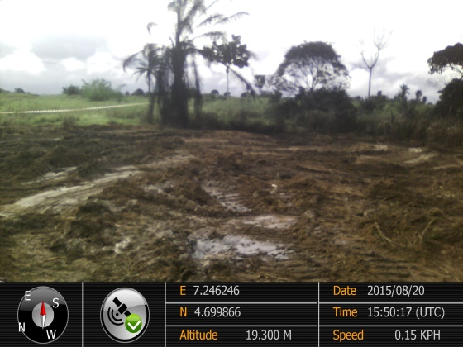
Fig. 4a Dykes dug for Containment Fig. 4b Repair work done & Area Backfilled.

